**RAJALAKSHMI ENGINEERING COLLEGE**

**RAJALAKSHMI NAGAR, THANDALAM – 602 105**



|  |
| --- |
| **CS23A34**  **USER INTERFACE AND DESIGN LAB** |
| **Laboratory Observation NoteBook** |

|  |
| --- |
| **Name :** SREE VARSSINI K S  **Year/Branch/Section :** II/CSE/D  **Register No. :** 230701332  **Semester :** IV  **Academic Year:** 2024-25 |

**Ex. No. : 3b**

**Register No. : 230701332 Name : Sree Varssini K S**



**Create a prototype with familiar and unfamiliar navigation elements. Evaluate ease of use with different user groups using wireflow**

**Aim:**

The aim is to design a prototype with both well-known and new navigation elements and measure user-friendliness across different user groups using Wireflow.

**Procedure:**

### Step 1: Plan Your Prototype

1. Define Navigation Elements:
   * *Familiar*: Standard menus, top bars, footers, and sidebar navigation.
   * *Unfamiliar*: Novel features such as hidden menus, gesture-based navigation, or custom swipes.
2. Sketch Your Layout:
   * Start with paper sketches or use tools like Figma or Sketch to visualize your design concepts.

### Step 2: Set Up Your Wireflow Project

1. Sign Up/Log In:
   * Head to Wireflow and create an account or log in if you already have one.
2. Start a New Project:
   * Click on "New Project" and name it. Choose a template or start from scratch.

### Step 3: Design the Prototype

1. Add Familiar Navigation Elements:
   * Drag and drop components like menus, header bars, buttons, etc., into your screens.
2. Incorporate Unfamiliar Elements:
   * Introduce hidden menus, unique gestures, or unexpected interactions.
3. Link Screens:
   * Use Wireflow's linking tools to create connections and transitions between screens.

### Step 4: Prepare for Usability Testing

1. Identify User Groups:
   * Segment users based on age, tech-savviness, or previous experience with similar products.
2. Recruit Participants:
   * Use online tools like UserTesting, forums, or social media to find participants.

### Step 5: Conduct Testing

1. Share the Prototype:
   * Invite users to interact with your prototype via a shareable link from Wireflow.
2. Test Sessions:
   * Ask users to complete tasks using both types of navigation. Observe their interactions and collect feedback.
3. Collect Feedback:
   * Utilize Wireflow's feedback features or conduct follow-up interviews to gather detailed responses.

### Step 6: Analyze and Report

1. Analyze Data:
   * Review the feedback and data collected. Look for patterns in ease of use and user preferences.
2. Compare Results:
   * Compare how different user groups interacted with familiar vs. unfamiliar navigation.
3. Create a Report:
   * Summarize your findings, highlighting insights, challenges, and recommendations

**Output:**

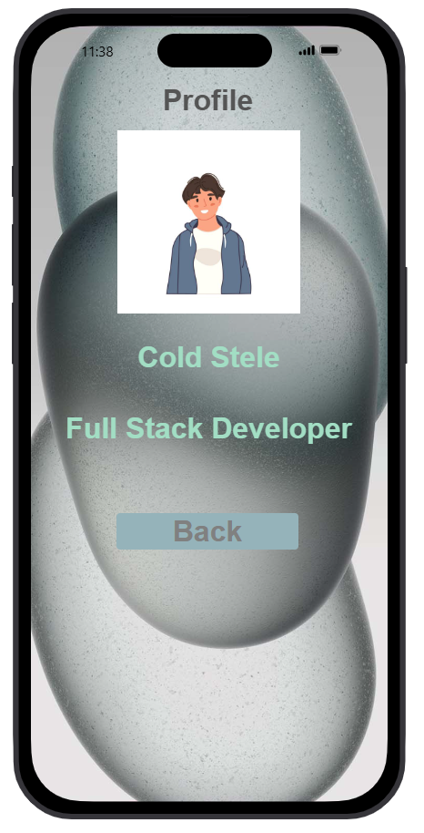 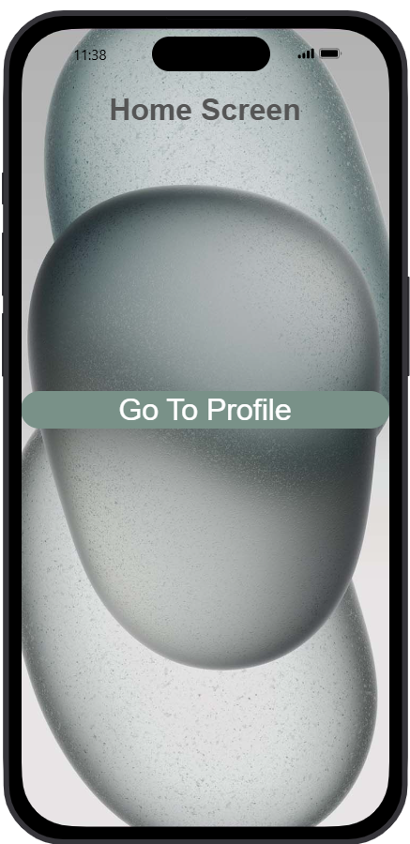

**Result:**

Hence the design of a prototype with both well-known and new navigation elements and measure user-friendliness across different user groups using Wireflow has been successfully studied and executed.